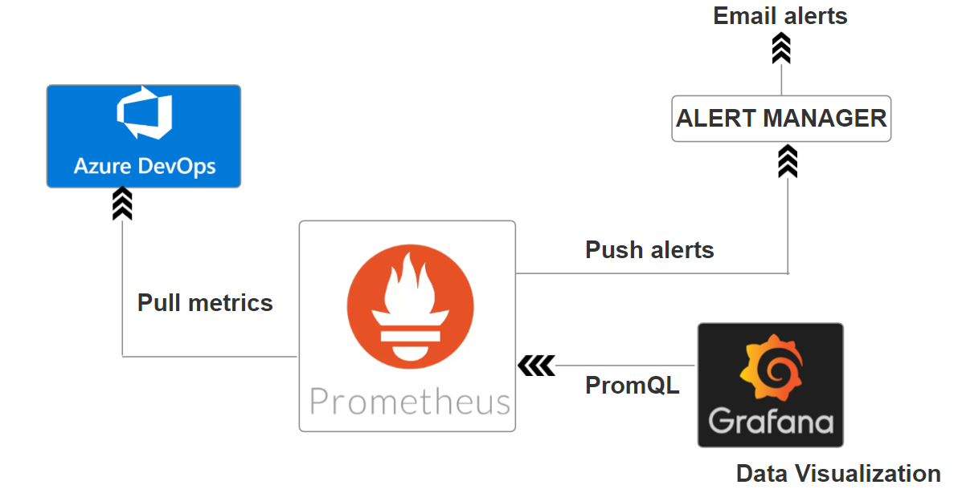

1. **Prometheus Setup:**

Install Prometheus.

Configure Prometheus to scrape the metrics endpoint

1. **Instrument Azure DevOps Pipelines:**

Use libraries (e.g., prometheus_client for Python) to collect metrics such as build success rates, duration, and test results.

1. **Elasticsearch Setup:**

* Install Elasticsearch to store and index logs.

1. **Push Logs on Build Failures:**

* Configure Azure DevOps to push logs to Elasticsearch during build failures using Filebeat or a custom script

1. **Grafana Setup:**

* Install Grafana.
* Add Prometheus and Elasticsearch as data sources in Grafana.
* Create dashboards for metrics and logs.

1. **Alerts and Notifications:**

* Set up alerting rules in Prometheus or Grafana.
* Configure alerts to notify via email.